

Spring2, 2020 – Additional Assessment (7%)
ECON252 – Macroeconomics

Name | ID

Problem1: (30 points)

INCOME | TAX | Disposable Income | Consumption | Saving | MPC | MPS
9000 | 5% |  |  | 900
10000 | 5% |  |  | 1200
11000 | 5% |  |  | 1500
12000 | 5% |  |  | 1800
13000 | 5% |  |  | 2100

- Calculate the MPC and MPS. Explain what your numbers mean. Show calculation

- Calculate the Multiplier. Explain the concept of multiplier.
Show calculation.

- If Consumption increases by 170 million, how this will affect equilibrium GDP?

Problem2: (40 points)

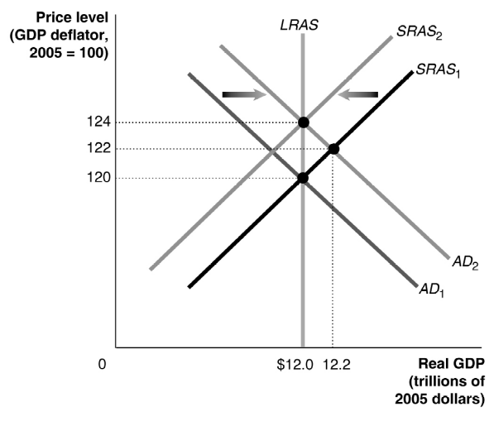
C
B
A

Use the aggregate demand and aggregate supply model to analyze the following business cycle phases. You will focus on the short-run effects and long-run effects. No need to do changes on the graph.
Answering the below questions will help you:
- Explain the economic condition in point C.
- Explain the business cycle phase shown by point A.
- Explain the business cycle phase shown by point B.

Problem 3: (30 points)
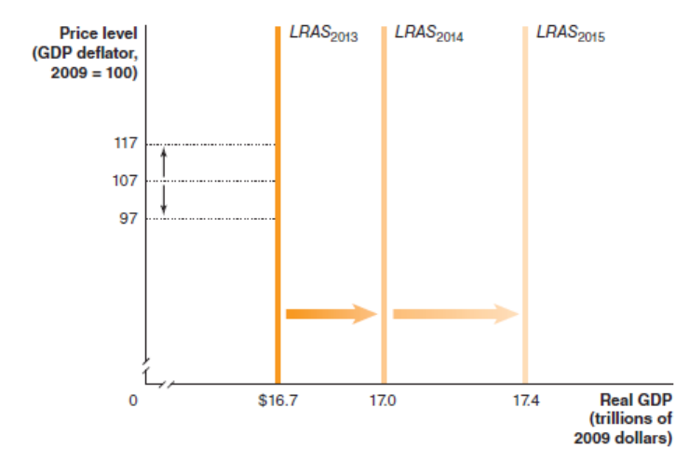
- Define Potential GDP.
- Explain factors that influence the Potential GDP and possible consequences.

